Gaming Mouse
Fast, Accurate And Reliable Optical Gaming Control
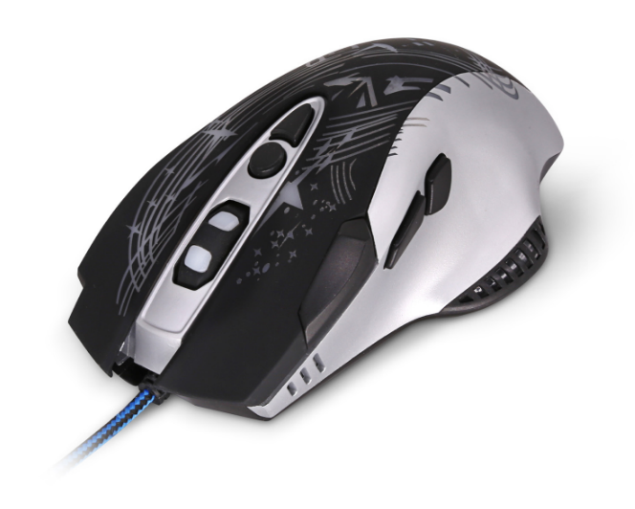

Descrption:

Precision HD Optical Tracking

Enjoy better on target hits, more accurate movement and faster game-play thanks to the integral optical tracking sensor with over x4 the resolution of regular optical mice. Works on almost any surface and gives a better experience in all your WindowsTM, MacTM and LinuxTM applications.

Multiple Hot-Button Functionality
Control more with your gaming mouse. With up to 7 separate, on-board hot-buttons, you now have the option to discard your keyboard for your favorite games. Logically placed while at the same time keeping fatigue to a minimum, the hot-buttons are ideal for regular applications too.
Tailored Design For Extended Gaming

Accurately sculptured design means you'll suffer less from fatigue, even during extended gaming sessions and with its exciting graphics, you can be sure you'll stand out from the crowd. With a generous, hard wearing USB cable as standard its ideal for almost all systems.

Features:

Super Accurate 3200DPI optical tracking

Ideal For Immersive Game-Play And Much More

Sculptured Design - Ideal For Extended Use

7-Button Hot Key Plus Scroll

Exciting Design Graphics

USB Plug n' Play - Works with any System

Specifications
- CPI Button：1200/1600/3200 CPI adjustable
- Buttons：Left, Right, Wheel and CPI, other multi-function
- Cable : 1.5M
- Wheel：1 Scrolling Wheel
- Power Consumption：3V DC 15mA
- Certificate: CE FCC ROHS
- Operating Temperature:0℃ to +45℃
- Operating Humidity:10%0 to 85 % RH
- Storage Temperature : -10℃ to +55℃
- Storage Humidity: 5% to 90 % RH

Product Code:
Part number: M990
Barcode: 8400800034601
Size: 13.5x10x.40 cm
Weight: 0.144 kg

